DATABASE DESIGN DETAILS for NNAP Car Dealers

**Prepared By:**

Neelesh Maharjan C0838743

Atul Shrestha C0845413

Nagaraju Tallapelly C0859913

Pratima Bhattarai Acharya C0846025  
Database Design Details for NNAP   
CSAT Summer 2022  
Alireza Moghaddam

1. Write a query that displays order id or order no., client_id, and client address.

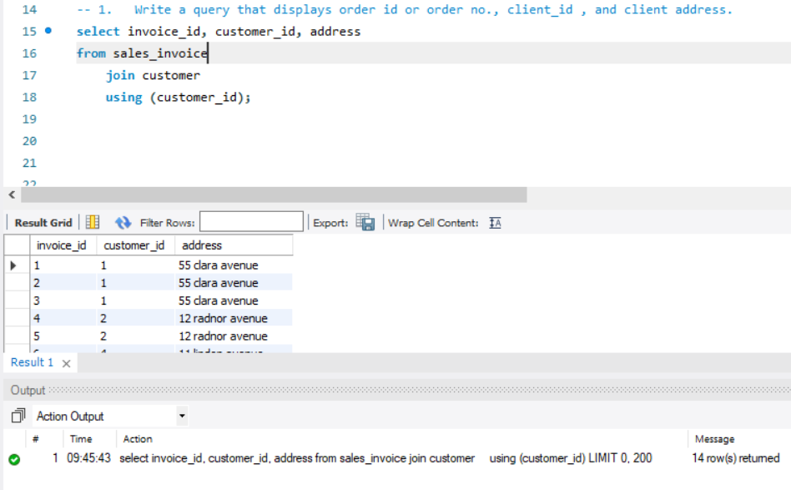

1. Write a query that displays the product/service id or product number that has been NOT sold to any customer.

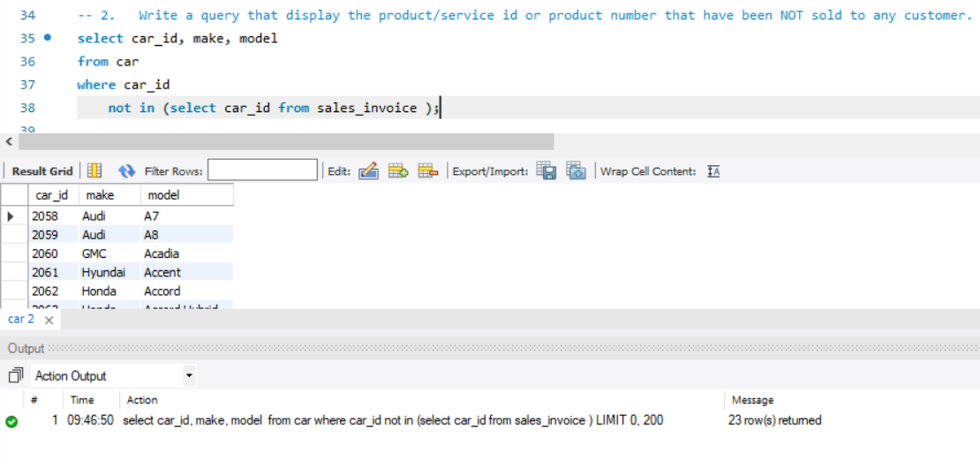

1. Write a query that display product/service information (productid, desc, cost, and another information of your choice) and it is related inventory or store if there is any.

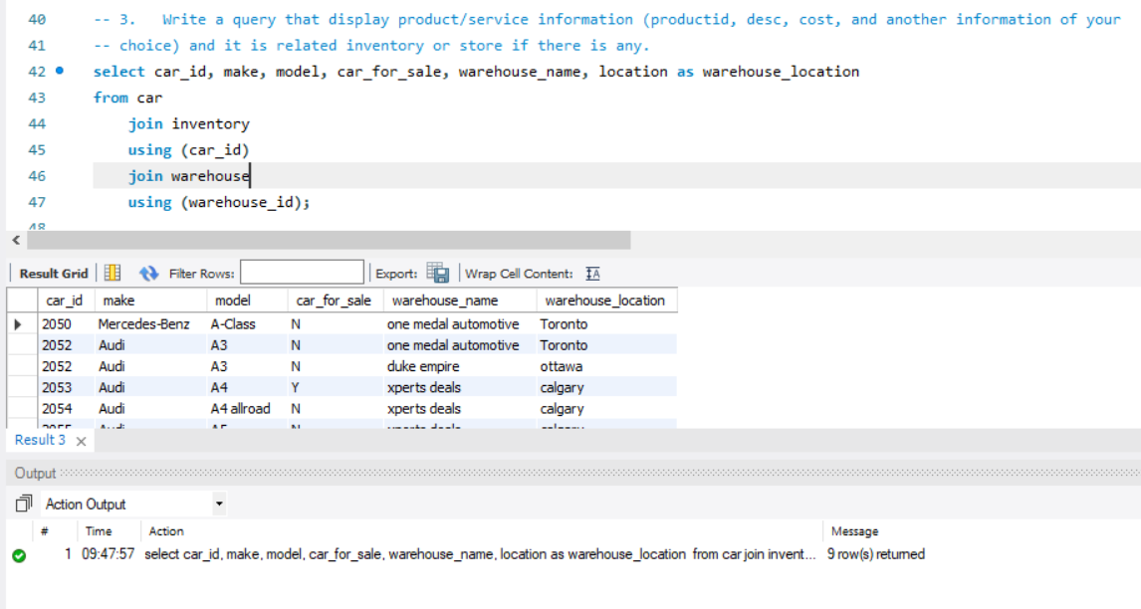

1. Write a query that displays the list of customers/clients who made the order and the list of the products/services in each order.

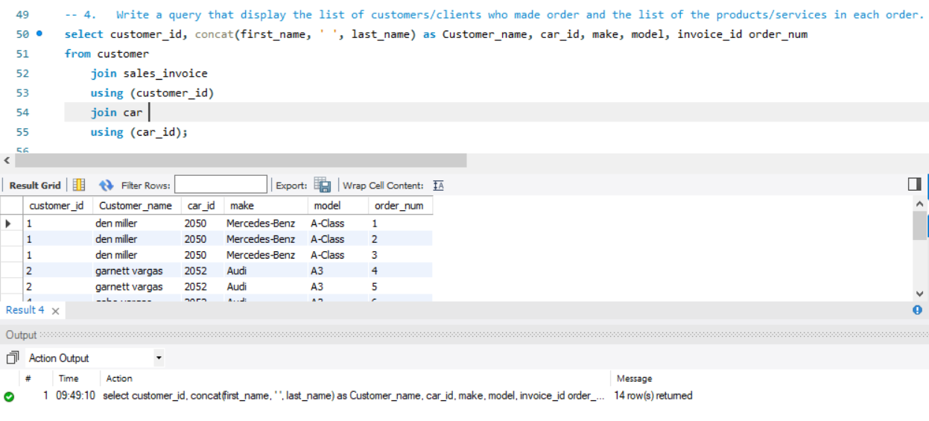

1. Write a query that displays the list of customers/clients who never made an order.

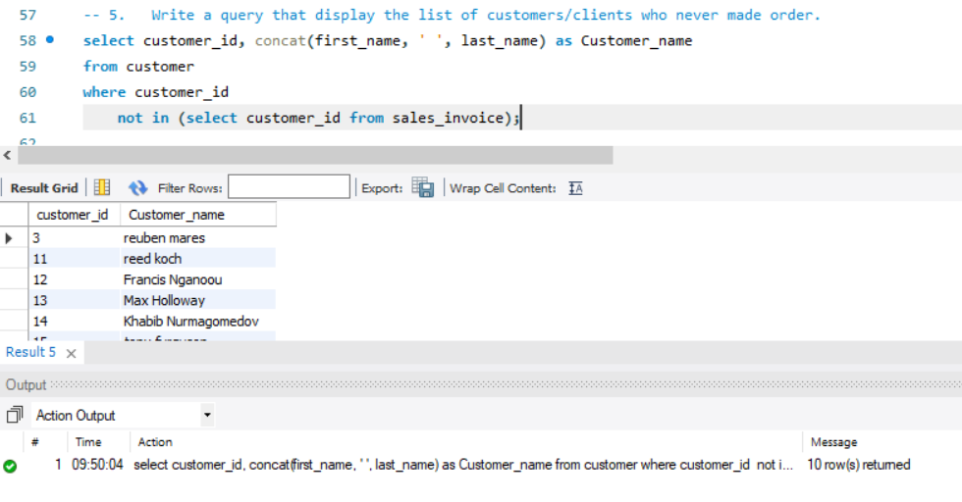

1. Write a query that displays the list of products/services that were never sold.

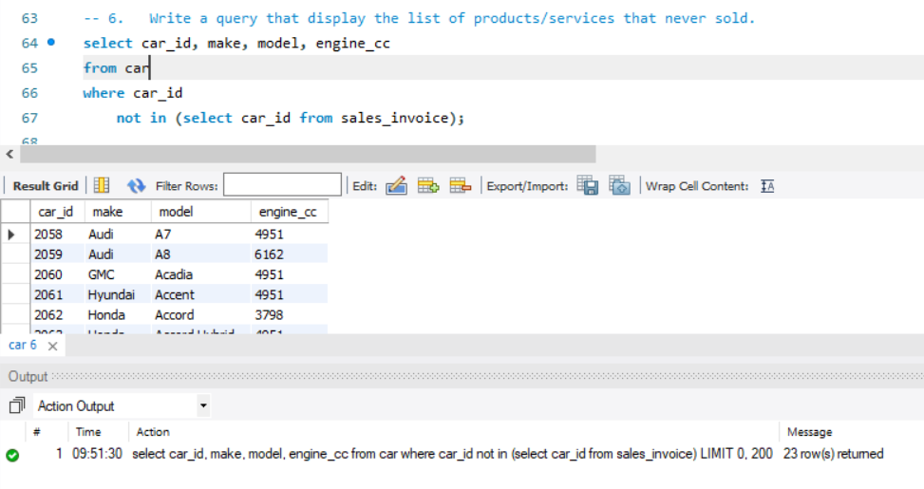

1. Write a query that displays the top customers/clients (received the most amount of services)

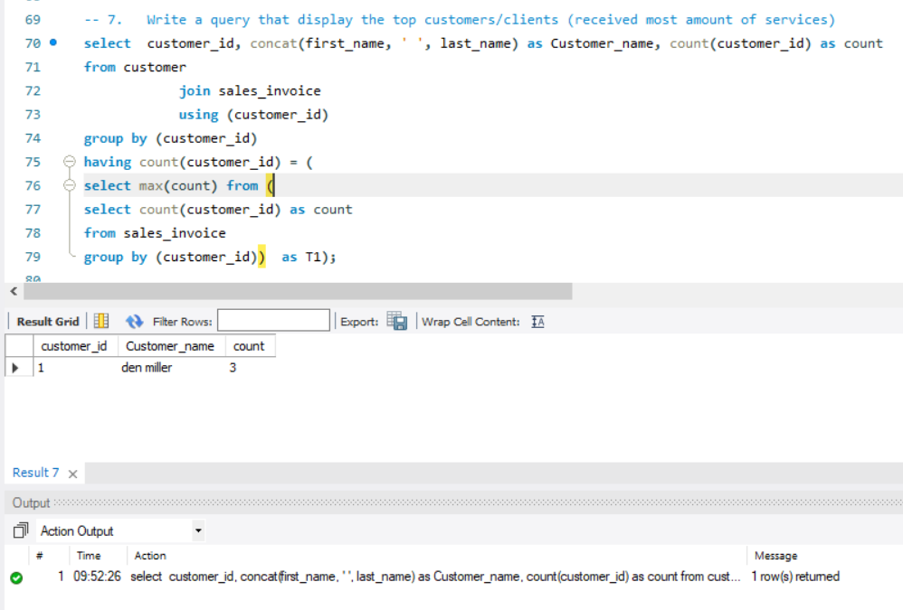

1. Write a query that displays the worst customers/clients (who received the lowest service in total or no service at all )

